Python Programming Lab Task Sets

Shaik. Yasmin
2505b04203

Set 4
- Q1. Create a function to reverse a list in Python. Use an AI tool to suggest alternative implementations. Test and compare the performance of each version.
(Each question carries 5 marks)
Ans:
PROMPT:
""" Create a function to reverse a list in Python. Provide at least three different implementations using different approaches (e.g., slicing, built-in functions, loops). Test and compare the performance of each version using the time module. Here is a Python implementation with multiple versions of the reverse function and performance testing:"""

CODE:
""" Create a function to reverse a list in Python. Provide at least three different implementations using different approaches (e.g., slicing, built-in functions, loops). Test and compare the performance of each version using the time module. Here is a Python implementation with multiple versions of the reverse function and performance testing:"""
import time
def reverse_list_v1(lst):
"""Reverse a list using slicing."""
return lst[::-1]
def reverse_list_v2(lst):
"""Reverse a list using the reversed() function."""
return list(reversed(lst))
def reverse_list_v3(lst):
"""Reverse a list using a for loop."""
reversed_lst = []
for item in lst:
reversed_lst.insert(0, item)
return reversed_lst

def test_performance(func, lst, iterations=10000):
start_time = time.time()
for _ in range(iterations):
func(lst)
end_time = time.time()
return end_time - start_time
if __name__ == "__main__":
test_list = list(range(1000)) # A sample list to reverse
iterations = 1000 # Number of iterations for performance testing

time_v1 = test_performance(reverse_list_v1, test_list, iterations)
time_v2 = test_performance(reverse_list_v2, test_list, iterations)
time_v3 = test_performance(reverse_list_v3, test_list, iterations)

print(f"Performance of reverse_list_v1 (slicing): {time_v1:.6f} seconds")
print(f"Performance of reverse_list_v2 (reversed function): {time_v2:.6f} seconds")
print(f"Performance of reverse_list_v3 (for loop): {time_v3:.6f} seconds")

# Determine the fastest implementation
times = {
"reverse_list_v1": time_v1,
"reverse_list_v2": time_v2,
"reverse_list_v3": time_v3
}

fastest = min(times, key=times.get)
print(f"The fastest implementation is {fastest} with a time of {times[fastest]:.6f} seconds")

OUTPUT:
Performance of reverse_list_v1 (slicing): 0.003548 seconds
Performance of reverse_list_v2 (reversed function): 0.003998 seconds
Performance of reverse_list_v2 (reversed function): 0.003998 seconds
Performance of reverse_list_v3 (for loop): 0.569721 seconds
Performance of reverse_list_v3 (for loop): 0.569721 seconds
The fastest implementation is reverse_list_v1 with a time of 0.003548 seconds
The fastest implementation is reverse_list_v1 with a time of 0.003548 seconds

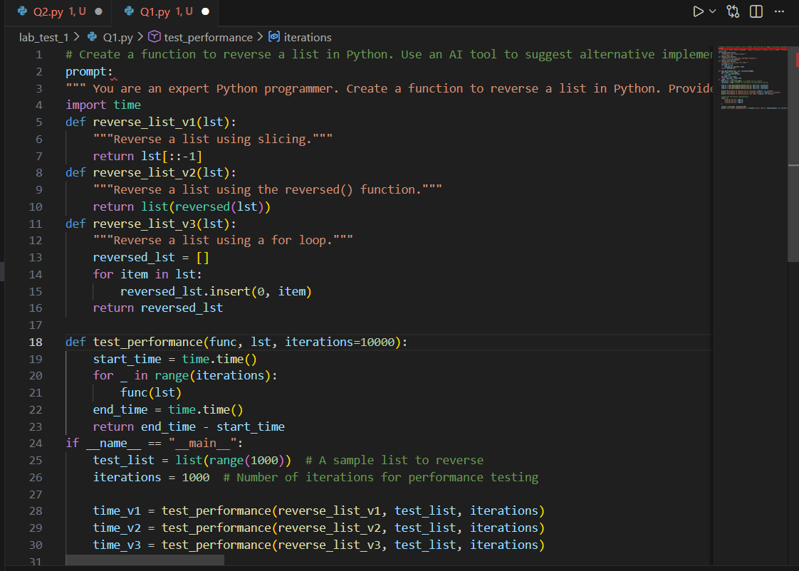
Figure 1: Code for different versions of reversing a list
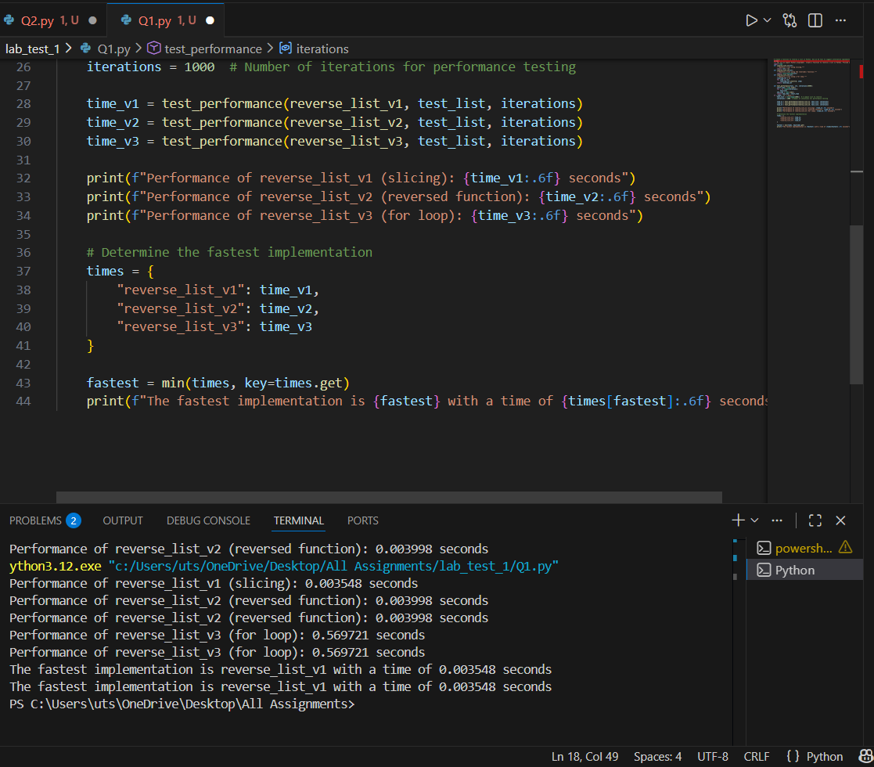
Figure 2: Output with different versions

- Q2. Design a few-shot prompt to guide an AI tool in writing code for a basic linked list with methods for insert and delete. Analyze the resulting code for correctness and completeness.
(Each question carries 5 marks)
Ans:
Prompt: """ You are an expert Python programmer. Write a class for a basic singly linked list with the following methods:
1. insert(value): Inserts a new node with the given value at the end of the list.
2. delete(value): Deletes the first node with the given value from the list.
Make sure to include proper handling for edge cases, such as deleting from an empty list or deleting a value that does not exist in the list. Provide a simple demonstration of how to use the linked list class.
Here is a Python implementation of a basic singly linked list with the specified methods:"""
CODE:
prompt:
""" You are an expert Python programmer. Write a class for a basic singly linked list with the following methods:
1. insert(value): Inserts a new node with the given value at the end of the list.
2. delete(value): Deletes the first node with the given value from the list.
Make sure to include proper handling for edge cases, such as deleting from an empty list or deleting a value that does not exist in the list. Provide a simple demonstration of how to use the linked list class.
Here is a Python implementation of a basic singly linked list with the specified methods:"""

class Node:
def __init__(self, value):
self.value = value
self.next = None
class SinglyLinkedList:
def __init__(self):
self.head = None

def insert(self, value):
new_node = Node(value)
if not self.head:
self.head = new_node
return
current = self.head
while current.next:
current = current.next
current.next = new_node

def delete(self, value):
if not self.head:
print("List is empty. Cannot delete.")
return
if self.head.value == value:
self.head = self.head.next
return
current = self.head
while current.next and current.next.value != value:
current = current.next
if current.next:
current.next = current.next.next
else:
print(f"Value {value} not found in the list.")

def display(self):
current = self.head
values = []
while current:
values.append(current.value)
current = current.next
print("Linked List:", " -> ".join(map(str, values)))

# Demonstration of the SinglyLinkedList class

linked_list = SinglyLinkedList()
linked_list.insert(10)
linked_list.insert(20)
linked_list.insert(30)
linked_list.display() # Output: Linked List: 10 -> 20 -> 30
linked_list.delete(20)
linked_list.display() # Output: Linked List: 10 -> 30
linked_list.delete(40) # Output: Value 40 not found in the list.
linked_list.delete(10)
linked_list.display() # Output: Linked List: 30
linked_list.delete(30)
linked_list.display() # Output: Linked List:

output:
Linked List: 10 -> 20 -> 30
Linked List: 10 -> 20 -> 30
Linked List: 10 -> 30
Value 40 not found in the list.
Linked List: 30
Linked List:

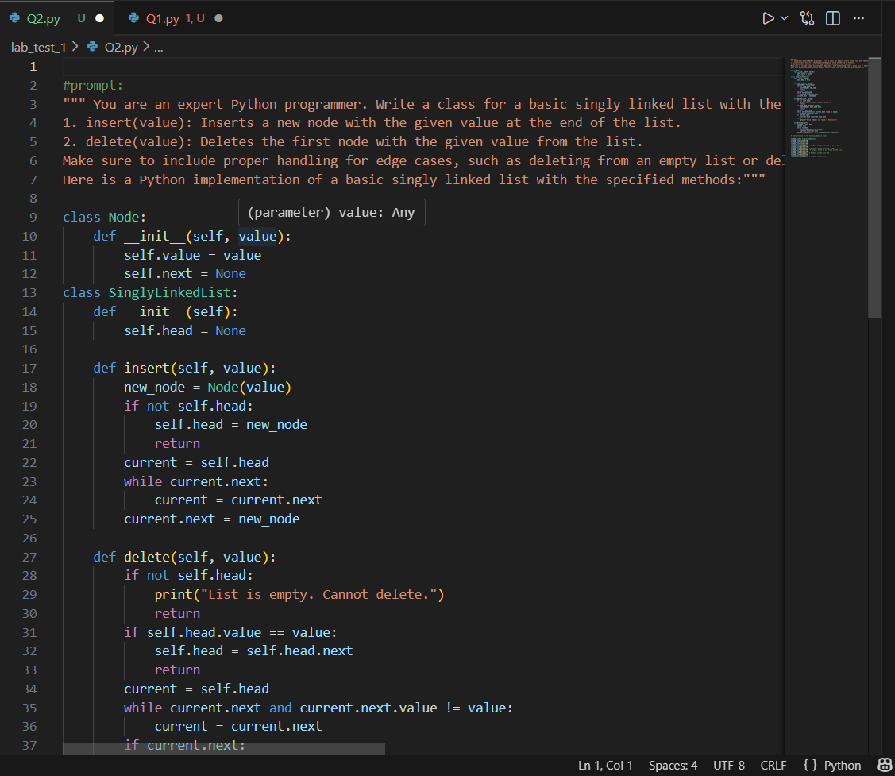
Figure 3: Code for methods insert and delete

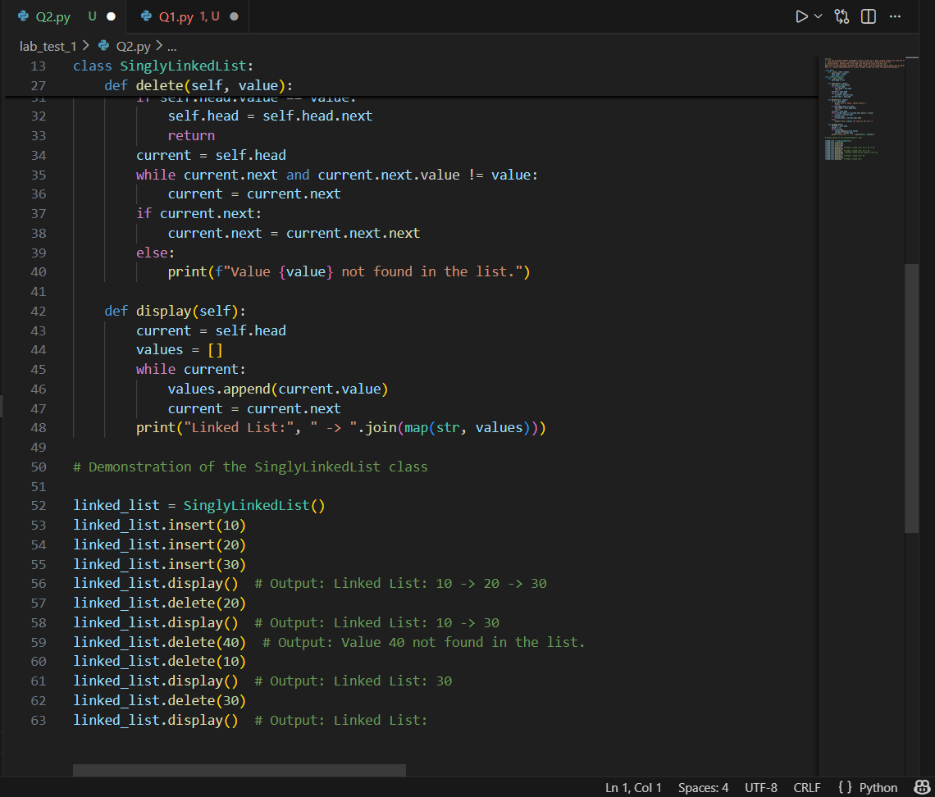
Figure 4: Code for insert and delete methods to display

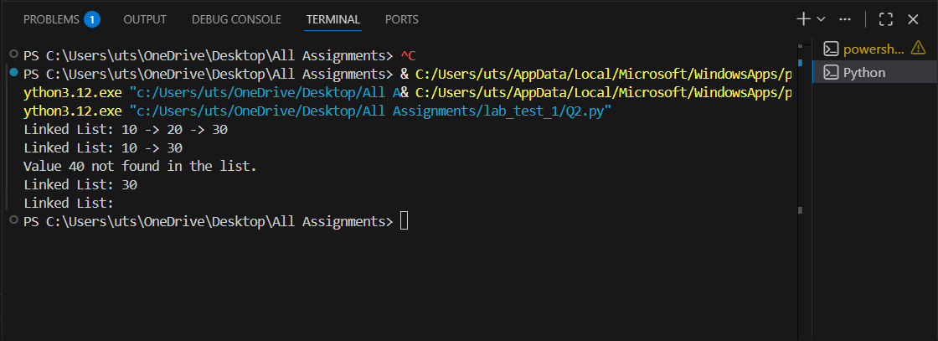
Figure 5: output of the code

